U.S. Airline Delay and Performance Analysis

1. Introduction
Air transportation plays a vital role in connecting people, businesses, and economies. However, flight delays and cancellations significantly affect passenger satisfaction, operational efficiency, and airline profitability. Analyzing airline performance helps stakeholders identify operational bottlenecks and implement strategies to improve service quality.
This project aims to analyze U.S. airline operational performance using SQL and Power BI. The study investigates flight delays, cancellations, airline performance, airport efficiency, and temporal trends to generate actionable business insights.

2. Problem Statement
Flight delays and cancellations create inconvenience for passengers and increase operational costs for airlines. Understanding the primary causes of delays, identifying high-performing and low-performing airlines, and analyzing airport and seasonal trends are essential for improving airline operations.

3. Objectives
The main objectives of this project are:
- Analyze flight delays and cancellation patterns.
- Measure airline performance using key performance indicators (KPIs).
- Evaluate airport operational efficiency.
- Study temporal trends by month, day of week, and time of day.
- Develop interactive Power BI dashboards for decision-making.
- Generate actionable recommendations for airlines and airport authorities.

4. Dataset Description
The project utilizes three datasets:

Flights Dataset
Contains flight operation details such as departure delays, arrival delays, cancellation information, and delay causes.

Airlines Dataset
Contains airline identifiers and airline names.

Airports Dataset
Contains airport information including airport names, cities, states, and airport codes.

Data Preparation
The datasets were imported into PostgreSQL and processed through:
- Data cleaning
- Missing value handling
- Data transformation
- Table integration using SQL JOIN operations.
- Create KPIs and perform EDA
- Creation of the integrated analysis table: us_airline_analysis

5. Methodology

Phase 1: Data Collection and Understanding
The flights, airlines, and airports datasets were collected and examined to understand their structure and attributes.

Phase 2: Data Cleaning and Integration
The data was cleaned and integrated using PostgreSQL. Missing values, inconsistencies, and redundant records were handled appropriately.

Before performing the analysis, I cleaned and prepared the dataset.
The dataset contained different types of missing values.
Type 1: Critical NULL Values
These are important business fields that should not be null.
Examples:
Airline Name
Origin Airport
Destination Airport
Flight Date
These columns are required for analysis and dashboard filtering.
During data validation, records with critical missing information were identified and checked.

Type 2: Logical NULL Values
Several delay-related and cancellation information columns contained NULL values.
Examples:
weather_delay
airline_delay
air_system_delay (NAS Delay)
security_delay
late_aircraft_delay
cancellation_reason
In this dataset, NULL does not necessarily mean missing data. Instead, it usually means:
No delay of that type occurred. NULL = 0 Minutes Delay
For analysis purposes, these NULL values were replaced with zero.
When a flight is not cancelled: Cancellation Reason = NULL

Phase 3: Exploratory Data Analysis and KPI Definition
The following KPIs were defined:
- Total Flights
- On-Time Performance (OTP) Rate
- Average Departure Delay
- Average Arrival Delay
- Cancellation Rate
- Delay Type Contribution

Phase 4: Dashboard Development
Three Power BI dashboards were developed:
- Overview Dashboard
- Airline Performance Dashboard
- Airport Performance & Temporal Trends Dashboard

Phase 5: Insight Generation
Dashboard analysis was used to identify trends, patterns, anomalies, and operational challenges.

6. SQL Analysis and KPI Results

Overall KPI Results
KPI | Value
Total Flights | 5.73 Million
OTP Rate | 81.87%
Average Departure Delay | 9.34 Minutes
Average Arrival Delay | 4.41 Minutes
Cancellation Rate | 1.54%
Diversion Rate | 0.26%

Delay Contribution Analysis
Delay Type | Percentage Contribution
Late Aircraft Delay | 39.84%
Airline Delay | 32.20%
NAS Delay | 22.88%
Weather Delay | 4.95%
Security Delay | 0.13%
The results indicate that Late Aircraft Delay is the most significant contributor to overall delays.

7. Dashboard Overview

Dashboard 1: Airline Delay Overview Dashboard
This dashboard presents:
- Total Flights
- OTP Rate
- Average Delays
- Cancellation Rate
- Delay Type Contribution
- Monthly OTP Trends

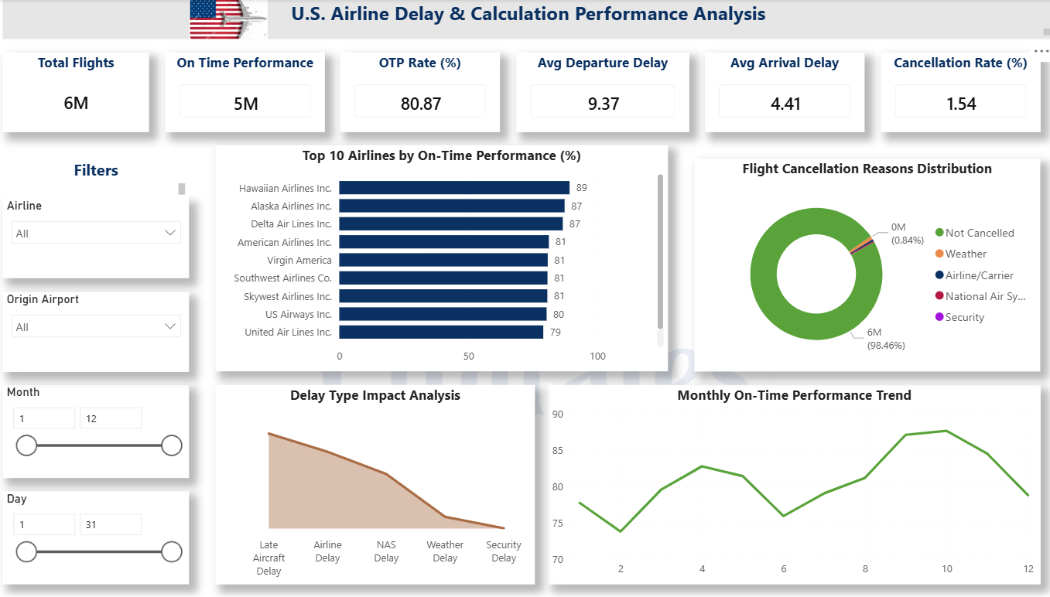

Dashboard 2: Airline Performance Dashboard
This dashboard presents:
- Best OTP Airline
- Worst OTP Airline
- Highest Delay Airline
- Lowest Delay Airline
- Flight Volume by Airline
- Cancellation Rate by Airline
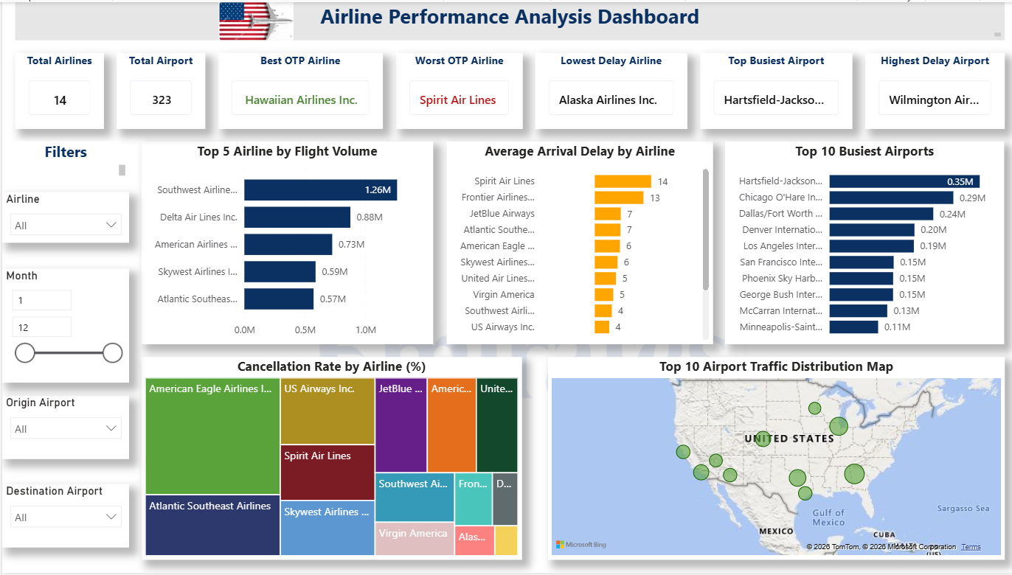

Dashboard 3: Airport Performance & Temporal Trends Dashboard
This dashboard presents:
- Best Month OTP
- Worst Month OTP
- Peak Delay Month
- Peak Delay Time
- Monthly Flight Trends
- Monthly Delay Trends
- Day-of-Week
- Performance

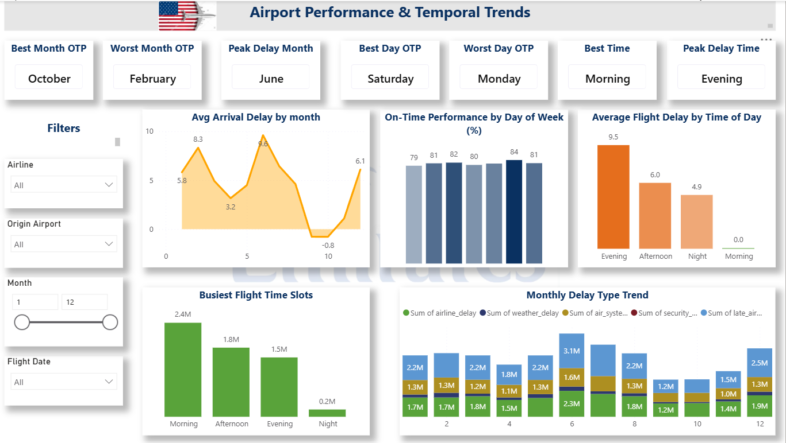

8. Key Findings and Analysis

Finding 1: Late Aircraft Delay Dominates
Late Aircraft Delay accounts for approximately 39.84% of total delay minutes, making it the largest contributor to flight delays.

Finding 2: Airline Delay is the Second Largest Cause
Airline Delay contributes approximately 32.20% of total delay minutes, indicating operational inefficiencies.

Finding 3: October Shows Best Performance
October achieved the highest On-Time Performance rate among all months.

Finding 4: February Shows Lowest Performance
February recorded the lowest OTP performance, suggesting seasonal operational challenges.

Finding 5: June Experiences Peak Delays
June recorded the highest average delay levels.

Finding 6: Evening Operations Experience Higher Delays
The analysis identified Evening as the peak delay period, indicating delay accumulation throughout the day.

Finding 7: Airline Performance Varies Significantly
Hawaiian Airlines demonstrated the strongest OTP performance, while Spirit Airlines showed relatively lower performance.

9. Recommendations

Recommendation 1: Improve Aircraft Turnaround Management
Since Late Aircraft Delay is the largest contributor, airlines should improve aircraft turnaround efficiency and scheduling.

Recommendation 2: Strengthen Night Operations
Additional resources, staffing, and operational monitoring should be allocated during night operations to reduce accumulated delays.

Recommendation 3: Seasonal Preparedness
Airlines and airports should implement special contingency plans during high-risk periods such as February and June.

10. Conclusion
This project successfully analyzed U.S. airline operational performance using PostgreSQL and Power BI. The study identified major delay causes, evaluated airline and airport efficiency, and examined temporal performance trends. The findings revealed that operational factors such as Late Aircraft Delay significantly influence airline performance. The developed dashboards provide a comprehensive and interactive platform for monitoring airline operations and supporting data-driven decision-making.
These findings can help airlines and airport authorities make data-driven decisions to improve operational efficiency and passenger satisfaction

